CE154 EXAMPLE DESIGN BRIEF
A profile website for the games developer Colin Ritman

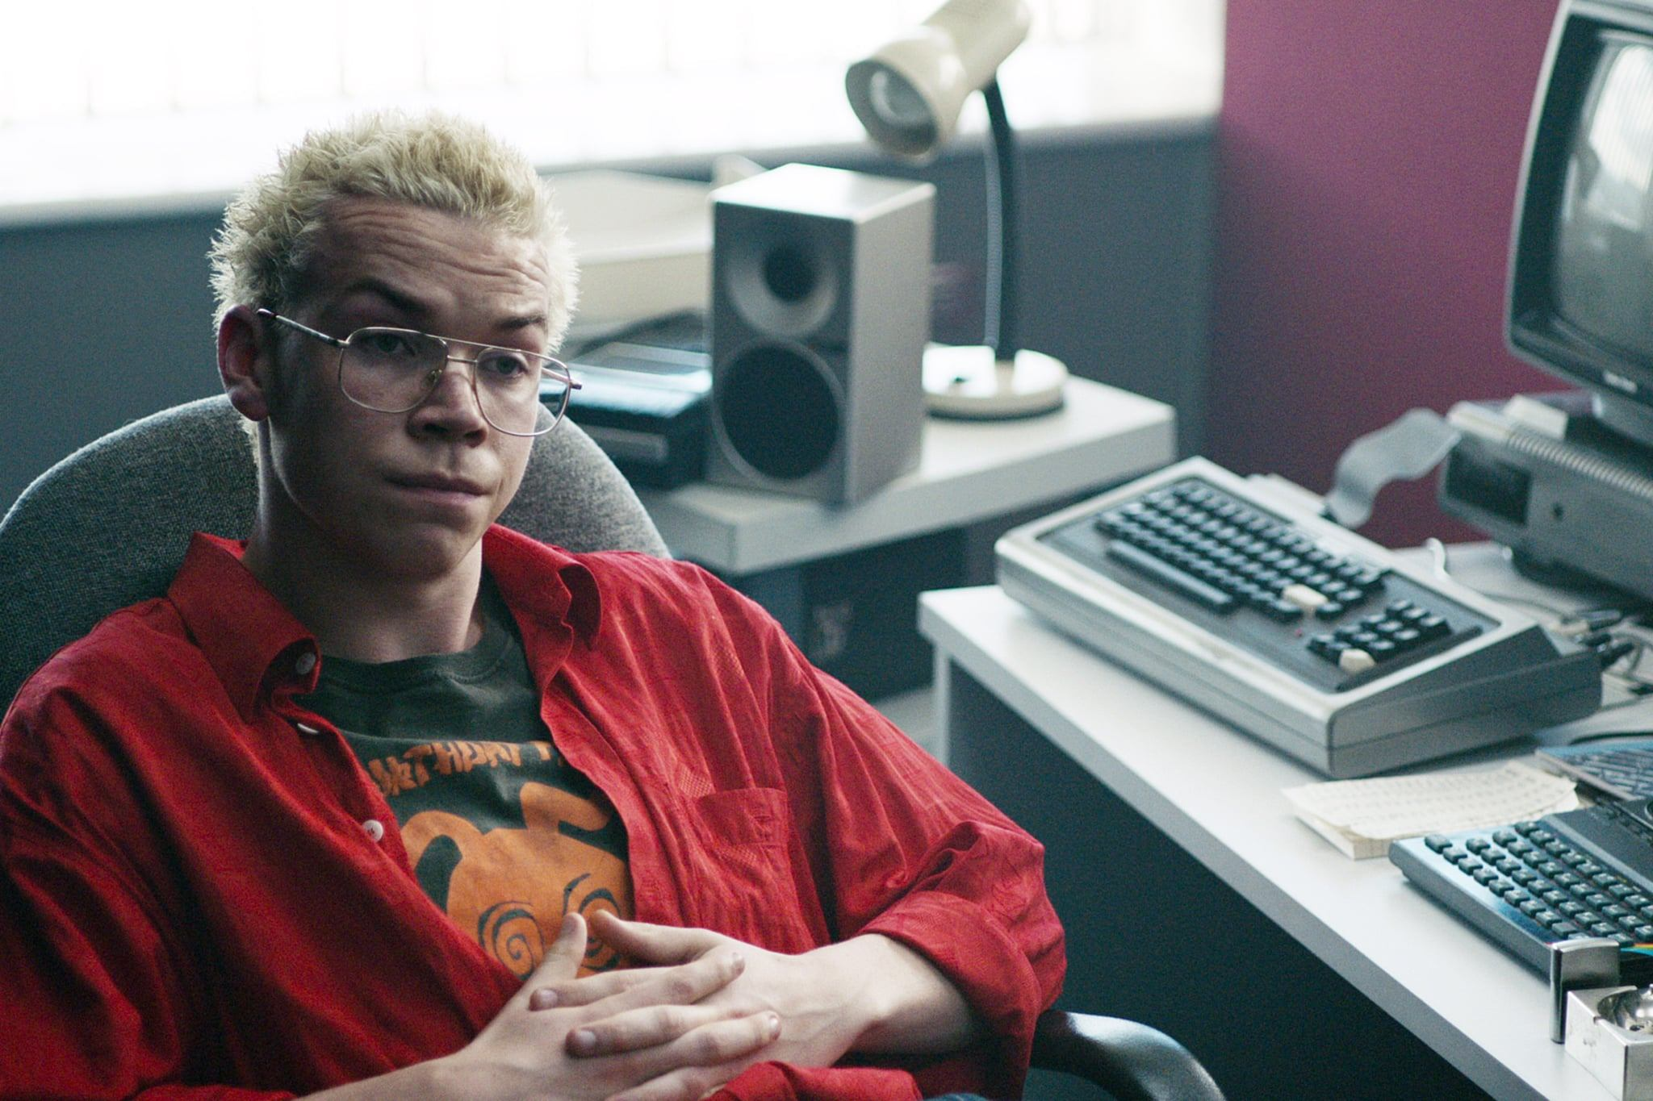
In England in July 1984 the fictional games creator Colin Ritman started working for the company Tuckersoft. Since then Colin has developed a number of exciting games and projects but feels it’s time to move on. He wants you to design him a profile website that showcases his talents and is graphically appealing. Colin is a big fan of 1980’s computer games of course, but always has an eye on future technology and music. He wants it optimised for mobile phone users and accessible to users with visual impairments.

[Colin Ritman is a fictional character from Charlie Brooker’s Black Mirror episode Bandersnatch, available on Netflix.]

Your website should focus on Colin’s skills and experiences to enhance his chances of getting a job in a computer games company, either directly from an employer, through an agency or through freelance work. For example, you could use the website to show off his familiarity with the history of the subject and any interesting or novel technologies he works with (imagine what the technology Colin is working with in 2019 and what is of value to employers).

The website must have key information about your client such as his past projects, awards, published research, invited talks at games conferences, etc. You need to consider who is likely to view this page and why in order to justify your design decisions to Colin. For example you might want to consider Colin’s fanbase, future employers and fellow games designers. Any materials you use must have the source credited.

Colin would like to understand the reasons for your design decisions, as well as some evidence that you have improved the design from your original draft before submitting to him.

Technical Requirements

The project must be submitted in a single zipped archive containing the following subfolders:

/project/ All html files (.html)
/project/images All website image files (.gif .jpg)
/project/css All css files (.css)
/project/docs All supporting documents (.doc .pdf .png .jpg .ppt .txt)

The website will be implemented in HTML and CSS. You may also use suitable imagery from the web so long as you credit the source in a separate file or in HTML comments. You must not use any technology other than HTML and CSS, ie no JavaScript, bootstrap, etc.

The website must have:
    - multicolour images formatted for Web use
    - at least 5 styled content pages
    - at least 3 external links on each page
    - suitable coding for accessibility
KEY

Green = Deliverable
Yellow = Requirement
Teal = Useful information and context

DELIVERABLES

- A website implemented in HTML and CSS
- A document justifying who will use the website and why (user personas and user stories)
- A document evidencing early stage evaluation of your designs (from design research to incorporating initial feedback from target user groups)

